**Loksabha Election 2024 Analysis**

1. Total Seats

select distinct count (parliament_constituency) as Total_seats

from constituencywise_results ;

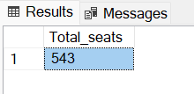

1. Total Number of seats in each state.

select s.State, count(cr.Parliament_Constituency) as No_of_seats

from states s

join statewise_results sr on s.State_ID = sr.State_ID

join constituencywise_results cr on sr.Parliament_Constituency = cr.Parliament_Constituency

group by s.State;

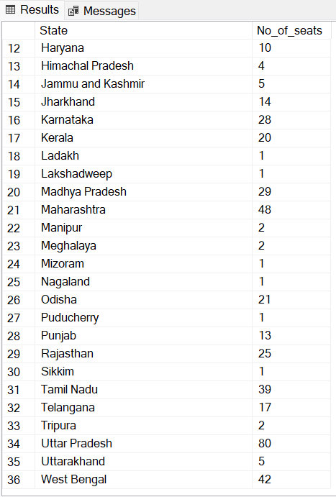

1. Total Seats won by NDA Alliance.

select sum ( case

when party in ( 'Bharatiya Janata Party - BJP',

'Telugu Desam - TDP',

'Shiv Sena - SHS',

'Janata Dal (United) - JD(U)',

'AJSU Party - AJSUP',

'Apna Dal (Soneylal) - ADAL',

'Asom Gana Parishad - AGP',

'Hindustani Awam Morcha (Secular) - HAMS',

'Janata Dal (Secular) - JD(S)',

'Janasena Party - JnP',

'Nationalist Congress Party - NCP',

'Lok Janshakti Party(Ram Vilas) - LJPRV',

'Rashtriya Lok Dal - RLD',

Sikkim Krantikari Morcha - SKM')

then [won]

else 0

end ) as Seats_won_by_NDA_Alliance

from partywise_results;

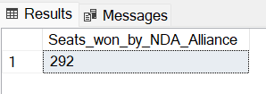

1. Seats won by each NDA Alliance party

select party, won

from partywise_results

where party in ( 'Bharatiya Janata Party - BJP',

'Telugu Desam - TDP',

'Shiv Sena - SHS',

'Janata Dal (United) - JD(U)',

'AJSU Party - AJSUP',

'Apna Dal (Soneylal) - ADAL',

'Asom Gana Parishad - AGP',

'Hindustani Awam Morcha (Secular) - HAMS',

'Janata Dal (Secular) - JD(S)',

'Janasena Party - JnP',

'Nationalist Congress Party - NCP',

'Lok Janshakti Party(Ram Vilas) - LJPRV',

'Rashtriya Lok Dal - RLD',

'Sikkim Krantikari Morcha - SKM')

order by won desc ;

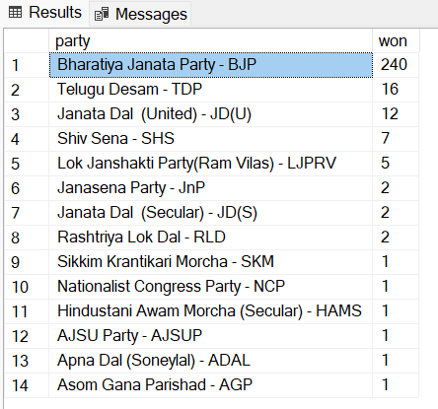

1. Total Seats won by I.N.D.I.A Alliance

select

sum (case

when party in (

'Indian National Congress - INC',

'Aam Aadmi Party - AAAP',

'All India Trinamool Congress - AITC',

'Bharat Adivasi Party - BHRTADVSIP',

'Communist Party of India  (Marxist) - CPI(M)',

'Communist Party of India  (Marxist-Leninist)  (Liberation) - CPI(ML)(L)',

'Communist Party of India - CPI',

'Dravida Munnetra Kazhagam - DMK',

'Indian Union Muslim League - IUML',

'Nat`Jammu & Kashmir National Conference - JKN',

'Jharkhand Mukti Morcha - JMM',

'Jammu & Kashmir National Conference - JKN',

'Kerala Congress - KEC',

'Marumalarchi Dravida Munnetra Kazhagam - MDMK',

'Nationalist Congress Party Sharadchandra Pawar - NCPSP',

'Rashtriya Janata Dal - RJD',

'Rashtriya Loktantrik Party - RLTP',

'Revolutionary Socialist Party - RSP',

'Samajwadi Party - SP',

'Shiv Sena (Uddhav Balasaheb Thackrey) - SHSUBT',

'Viduthalai Chiruthaigal Katchi - VCK'

) then [Won]

Else 0

End ) as INDIA_Total_Seats_Won

from

    partywise_results ;

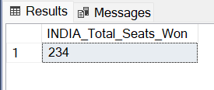

1. Seats won by each I.N.D.I.A Alliance party

select party, won

from partywise_results

where party in (

'Indian National Congress - INC',

'Aam Aadmi Party - AAAP',

'All India Trinamool Congress - AITC',

'Bharat Adivasi Party - BHRTADVSIP',

'Communist Party of India (Marxist) - CPI(M)',

'Communist Party of India (Marxist-Leninist) (Liberation) - CPI(ML)(L)',

'Communist Party of India - CPI',

'Dravida Munnetra Kazhagam - DMK',

'Indian Union Muslim League - IUML',

'Nat`Jammu & Kashmir National Conference - JKN',

'Jharkhand Mukti Morcha - JMM',

'Jammu & Kashmir National Conference - JKN',

'Kerala Congress - KEC',

'Marumalarchi Dravida Munnetra Kazhagam - MDMK',

'Nationalist Congress Party Sharadchandra Pawar - NCPSP',

'Rashtriya Janata Dal - RJD',

'Rashtriya Loktantrik Party - RLTP',

'Revolutionary Socialist Party - RSP',

'Samajwadi Party - SP',

'Shiv Sena (Uddhav Balasaheb Thackrey) - SHSUBT',

'Viduthalai Chiruthaigal Katchi - VCK')

order by won;

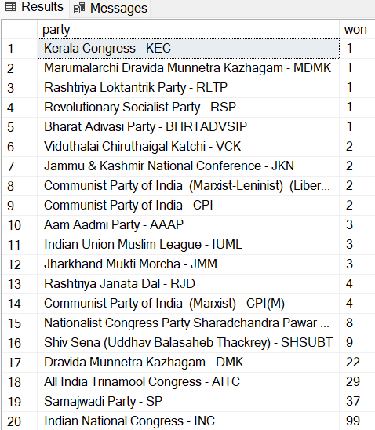

1. Add a column in partywise_result table to show the Alliance.

alter table partywise_results

add party_alliance varchar(50);

update partywise_results

set party_alliance = 'I.N.D.I.A'

where party in (

'Indian National Congress - INC',

'Aam Aadmi Party - AAAP',

'All India Trinamool Congress - AITC',

'Bharat Adivasi Party - BHRTADVSIP',

'Communist Party of India (Marxist) - CPI(M)',

'Communist Party of India (Marxist-Leninist) (Liberation) - CPI(ML)(L)',

'Communist Party of India - CPI',

'Dravida Munnetra Kazhagam - DMK',

'Indian Union Muslim League - IUML',

'Jammu & Kashmir National Conference - JKN',

'Jharkhand Mukti Morcha - JMM',

'Kerala Congress - KEC',

'Marumalarchi Dravida Munnetra Kazhagam - MDMK',

'Nationalist Congress Party Sharadchandra Pawar - NCPSP',

'Rashtriya Janata Dal - RJD',

'Rashtriya Loktantrik Party - RLTP',

'Revolutionary Socialist Party - RSP',

'Samajwadi Party - SP',

'Shiv Sena (Uddhav Balasaheb Thackrey) - SHSUBT',

'Viduthalai Chiruthaigal Katchi - VCK'

);

update partywise_results

set party_alliance = 'NDA'

where party in (

'Bharatiya Janata Party - BJP',

'Telugu Desam - TDP',

'Janata Dal (United) - JD(U)',

'Shiv Sena - SHS',

'AJSU Party - AJSUP',

'Apna Dal (Soneylal) - ADAL',

'Asom Gana Parishad - AGP',

'Hindustani Awam Morcha (Secular) - HAMS',

'Janasena Party - JnP',

'Janata Dal (Secular) - JD(S)',

'Lok Janshakti Party(Ram Vilas) - LJPRV',

'Nationalist Congress Party - NCP',

'Rashtriya Lok Dal - RLD',

'Sikkim Krantikari Morcha - SKM'

);

update partywise_results

set party_alliance = 'OTHER'

where party_alliance IS NULL;

select * from partywise_results;

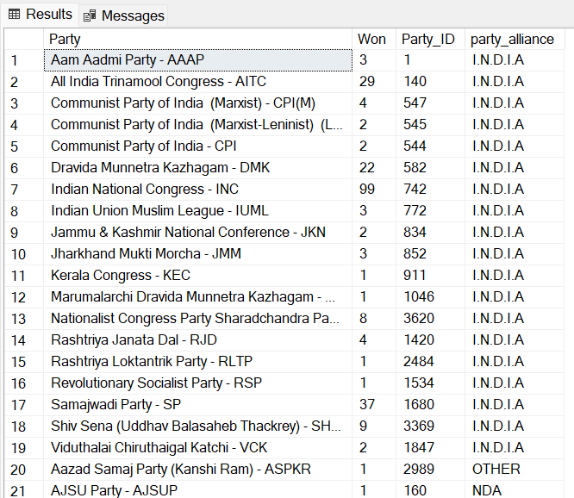

1. Total Seats won by Alliances

select party_alliance, sum(won) as seats_won_by_alliances

from partywise_results

group by party_alliance ;

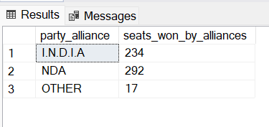

1. **Winning candidate's name, their party name, total votes, and the margin of victory for a specific state and constituency?**

select cr.winning_candidate, pr.party, cr.total_votes, cr.margin, s.state, constituency

from constituencywise_results cr

join partywise_results pr on pr.Party_ID = cr.Party_ID

join statewise_results sr on sr.Parliament_Constituency = cr.Parliament_Constituency

join states s on sr.State_ID= s.State_ID ;

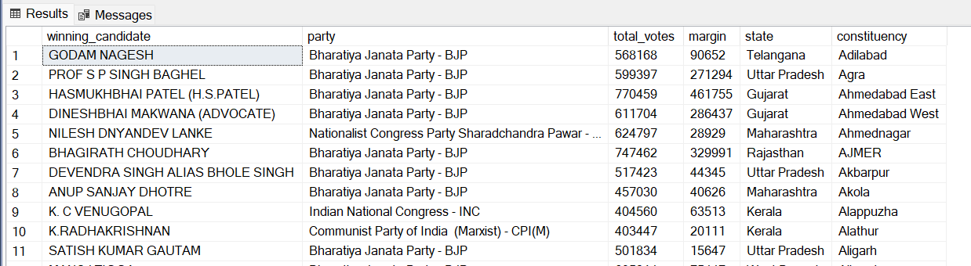

1. **What is the distribution of EVM votes versus postal votes for candidates in a specific constituency?**

select

cd.Candidate,

cd.Party,

cd.EVM_Votes,

cd.Postal_Votes,

cd.Total_Votes,

cr.Constituency_Name

from

constituencywise_details cd

join

constituencywise_results cr on cd.Constituency_ID = cr.Constituency_ID;

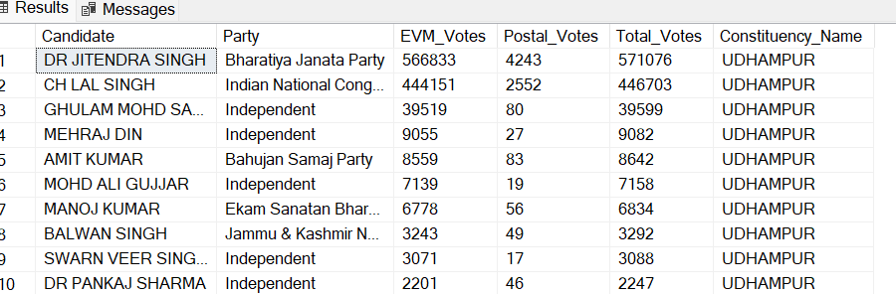

1. Which parties won the most seats in a State, and how many seats did each party win?

select

p.Party,

count(cr.Constituency_ID) as Seats_Won

from

constituencywise_results cr

join

partywise_results p on cr.Party_ID = p.Party_ID

join

statewise_results sr on cr.Parliament_Constituency = sr.Parliament_Constituency

join states s on sr.State_ID = s.State_ID

where

s.state = 'Uttar Pradesh'

group by

p.Party

order by

Seats_Won desc;

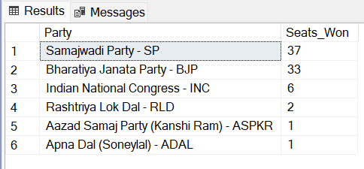

1. What is the total number of seats won by each party alliance (NDA, I.N.D.I.A, and OTHER) in each state for the India Elections 2024

select

s.State AS State_Name,

sum(case when p.party_alliance = 'NDA' then 1 else 0 end) as NDA_Seats_Won,

sum(case when p.party_alliance = 'I.N.D.I.A' then 1 else 0 end) as INDIA_Seats_Won,

sum(case when p.party_alliance = 'OTHER' then 1 else 0 end) as OTHER_Seats_Won

from

constituencywise_results cr

join

partywise_results p on cr.Party_ID = p.Party_ID

join

statewise_results sr on cr.Parliament_Constituency = sr.Parliament_Constituency

join

states s on sr.State_ID = s.State_ID

where

p.party_alliance IN ('NDA', 'I.N.D.I.A', 'OTHER')

group by

s.State

order by

s.State;

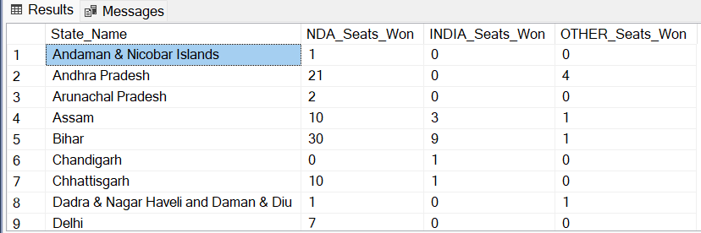

1. **Which candidate received the highest number of EVM votes in each constituency (Top 10)?**

select top 10

cr.Constituency_Name,

cd.Constituency_ID,

cd.Candidate,

cd.EVM_Votes

from

constituencywise_details cd

join

constituencywise_results cr on cd.Constituency_ID = cr.Constituency_ID

where

cd.EVM_Votes = (

select max(cd1.EVM_Votes)

from constituencywise_details cd1

where cd1.Constituency_ID = cd.Constituency_ID

)

order by

cd.EVM_Votes desc;

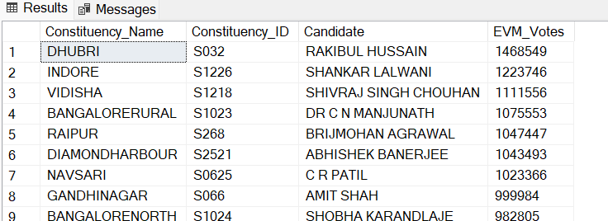

1. Which candidate won and which candidate was the runner-up in each constituency of State for the 2024 elections?

with RankedCandidates as (

select

cd.Constituency_ID,

cd.Candidate,

cd.Party,

cd.EVM_Votes,

cd.Postal_Votes,

cd.EVM_Votes + cd.Postal_Votes as Total_Votes,

ROW_NUMBER() over (partition by cd.Constituency_ID order by cd.EVM_Votes + cd.Postal_Votes desc) as VoteRank

from

constituencywise_details cd

join

constituencywise_results cr on cd.Constituency_ID = cr.Constituency_ID

join

statewise_results sr on cr.Parliament_Constituency = sr.Parliament_Constituency

join

states s on sr.State_ID = s.State_ID

where

s.State = 'Maharashtra'

)

select

cr.Constituency_Name,

max(case when rc.VoteRank = 1 then rc.Candidate end) as Winning_Candidate,

max(case when rc.VoteRank = 2 then rc.Candidate end) as Runnerup_Candidate

from

RankedCandidates

rc

join

constituencywise_results cr on rc.Constituency_ID = cr.Constituency_ID

group by

cr.Constituency_Name

order by

cr.Constituency_Name;

